Project Title:

**SmartShelfX – AI-Based Inventory Forecast & Auto-Restock**

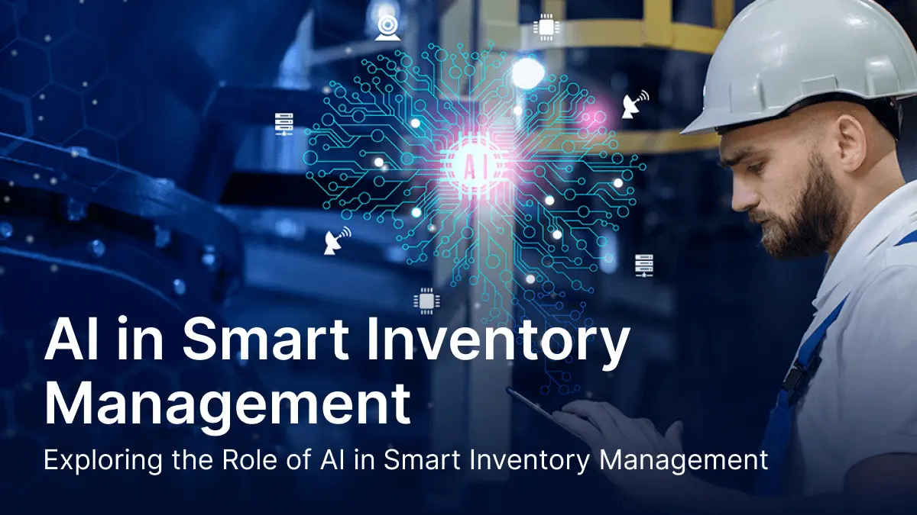

**Project Statement:**

SmartShelfX is a next-generation inventory management platform designed to optimize stock levels using AI-powered demand forecasting. The system analyzes historical sales, seasonal trends, and real-time data to recommend and automate restocking operations. Built using Angular 19 for the frontend, Node.js (Express) for the backend, and MySQL for data storage, SmartShelfX provides a smart dashboard, real-time alerts, and automated purchase order suggestions, ensuring minimal stockouts and overstocking.

**1. User & Role Management**

**Services**:

* Login/Register (Admin, Warehouse Manager, Vendor)
* JWT-based security
* Dashboard with role-based navigation

**Expected Output Screenshot:**

* Login page
* Dashboard cards like: “Inventory Level”, “Low Stock Alerts”, “Auto-Restock Status”

**2. Inventory Catalog & Product Management**

**Services**:

* Add/edit/delete products
* Product details: SKU, category, vendor, reorder level, current stock
* Batch import (CSV)

**Expected Output Screenshot:**

* Product form + inventory table
* Filters: Category, Vendor, Stock status

**3. Stock-In / Stock-Out Transactions**

**Services**:

* Record incoming shipments & outgoing sales/dispatches
* Track timestamps, quantities, and handlers
* Calculate real-time inventory

**Expected Output Screenshot:**

* Stock-in/out forms
* Transaction history table

**4. AI-Based Demand Forecasting**

**Services**:

* Analyze historical stock data
* Predict demand for each item (daily/weekly)
* Highlight products at risk of stockout

**AI Integration:**

* Python microservice (TensorFlow/Scikit-learn) triggered from Node.js
* Predict future quantity needs

**Expected Output Screenshot:**

* Line chart for forecast trends
* Prediction table: SKU | Forecast | Current Stock | Action

**5. Auto-Restock Recommendation & Purchase Orders**

**Services**:

* AI suggests items to reorder
* Auto-generate purchase order (PO) for vendor approval
* Email/SMS notification to vendors

**Expected Output Screenshot:**

* “Suggested Restock” table
* PO generation modal with pre-filled fields

**6. Alerts & Notifications Module**

**Services**:

* Low stock alerts
* Expiry alerts (for perishable goods)
* Vendor response tracking

**Expected Output Screenshot:**

* Notification bell with dropdown
* Alert table (sortable + dismiss option)

**7. Analytics Dashboard & Reports**

**Services**:

* Inventory trends
* Monthly purchase/sales comparison
* Top restocked items
* Export as Excel/PDF

**Expected Output Screenshot:**

* Dashboard with pie chart, bar graph, restock vs demand visual

**Technology Stack**

|  |  |
| --- | --- |
| Layer | Technology |
| Frontend | Angular 19, Angular Material |
| Backend | Node.js (Express), REST APIs |
| Database | MySQL with Sequelize ORM |
| AI Engine | Python ML service via REST (forecasting) |
| Charts | Chart.js / ngx-charts |

**Expected outputs:**

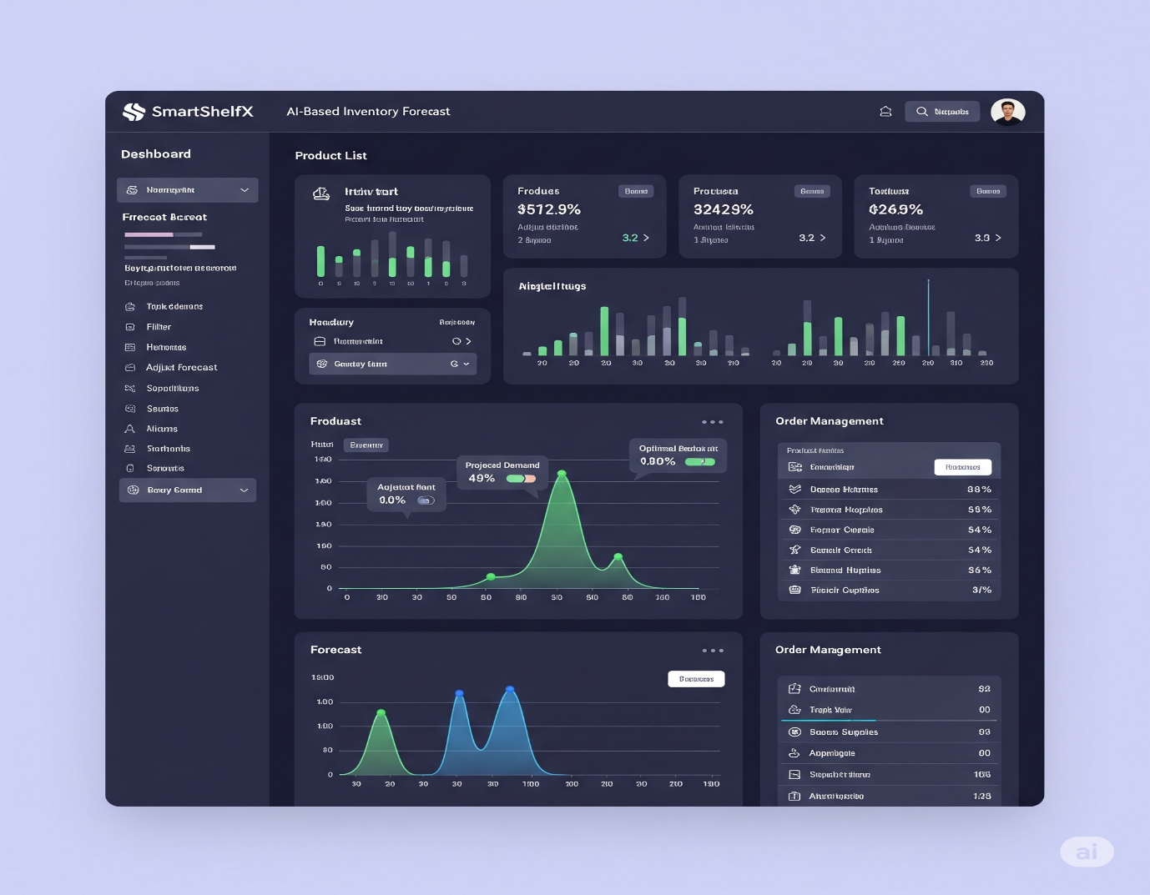

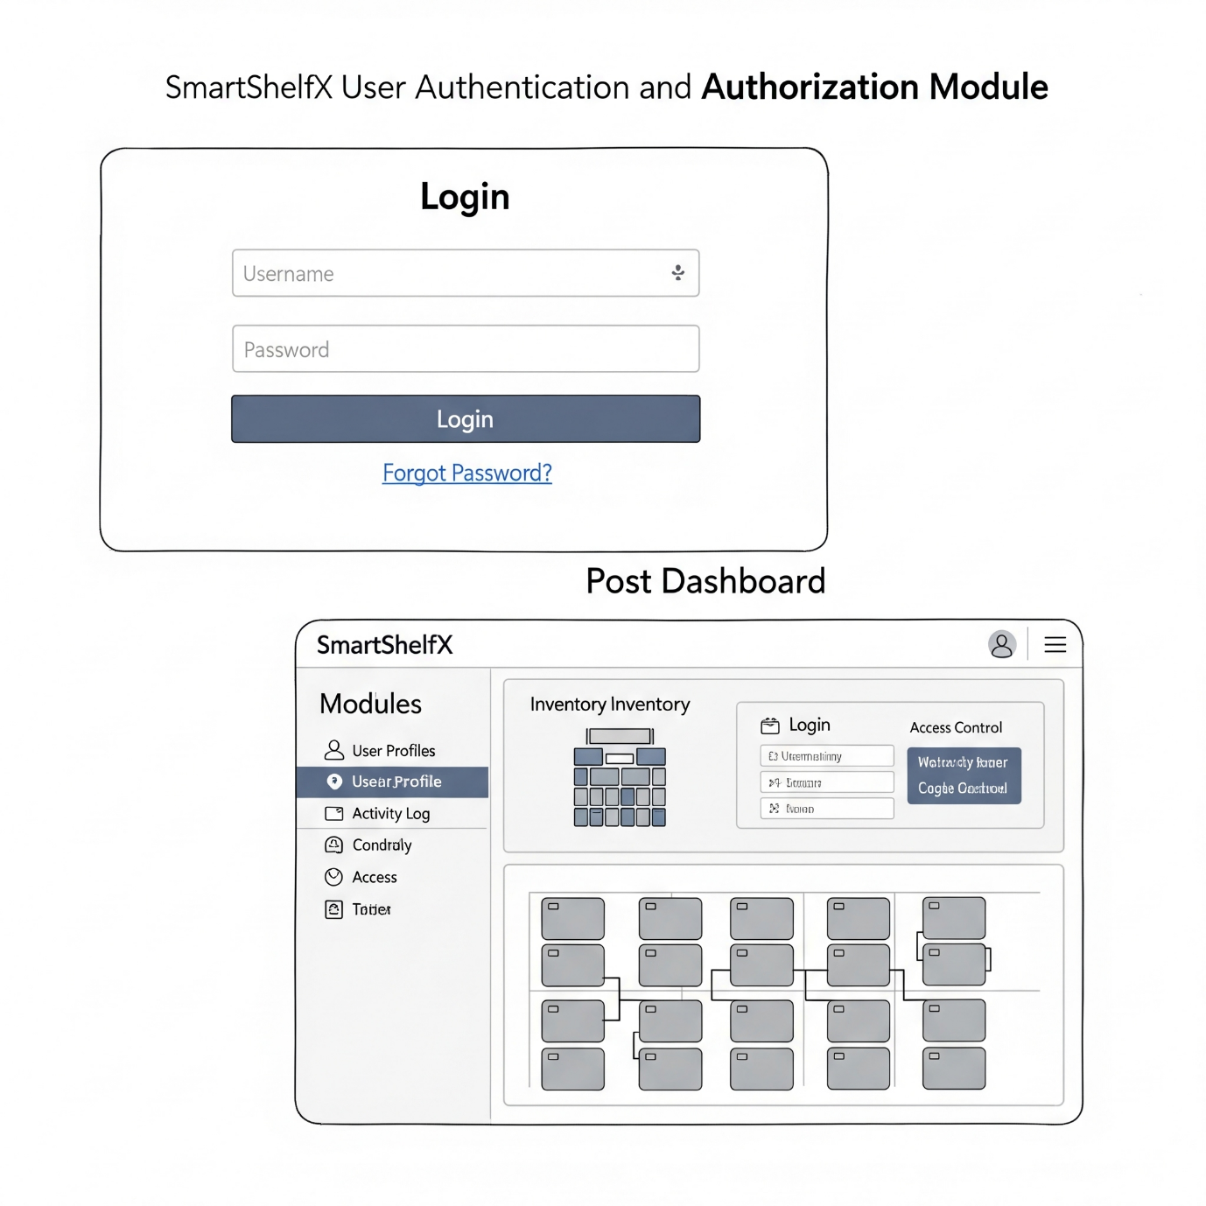

**MySQL Database Schema (Sample)**

CREATE TABLE users (  
 id BIGINT AUTO_INCREMENT PRIMARY KEY,  
 name VARCHAR(100),  
 email VARCHAR(100),  
 password VARCHAR(255),  
 role ENUM('ADMIN', 'MANAGER', 'VENDOR')  
);  
  
CREATE TABLE products (  
 id BIGINT AUTO_INCREMENT PRIMARY KEY,  
 name VARCHAR(100),  
 sku VARCHAR(50) UNIQUE,  
 vendor_id BIGINT,  
 reorder_level INT,  
 current_stock INT,  
 category VARCHAR(100),  
 FOREIGN KEY (vendor_id) REFERENCES users(id)  
);  
  
CREATE TABLE stock_transactions (  
 id BIGINT AUTO_INCREMENT PRIMARY KEY,  
 product_id BIGINT,  
 quantity INT,  
 type ENUM('IN', 'OUT'),  
 timestamp DATETIME,  
 handled_by BIGINT,  
 FOREIGN KEY (product_id) REFERENCES products(id)  
);  
  
CREATE TABLE purchase_orders (  
 id BIGINT AUTO_INCREMENT PRIMARY KEY,  
 product_id BIGINT,  
 vendor_id BIGINT,  
 quantity INT,  
 status ENUM('PENDING', 'APPROVED', 'DISPATCHED'),  
 created_at DATETIME,  
 FOREIGN KEY (product_id) REFERENCES products(id),  
 FOREIGN KEY (vendor_id) REFERENCES users(id)  
);